Lab9 Stochastic crossbridge model

Zhuoyang Chen 11/08/2019

**Model and baseline run**

The document already has a detailed description of this model. Several parameter settings can be explained.

alpha**=**14**;** % /s probability per unit time for attachment

beta**=**126**;** % /s probability per unit time for detachment

alpha and beta are the propensities of attachment and detachment. Values of them seem to be taken for convenience, but we can still expect that the average attached crossbridge would be 10% of the total possible crossbridge, as alpha / (alpha + beta) = 14 / (14 + 126) = 0.1 and I believe that this proportion is set on purpose for easy illustration.

dt**=**0.01**/(**alpha**+**beta**);** % s duration of time step

tend**=**0.25**;** % simulation time

Consider that probability of attachment and detachment is changing along time, with a step of dt. A total simulation time of 0.25 second reflects the muscle contraction time.

In the file, dt equals to a pre-set 0.01 divided by alpha + beta:

prob**=(**beta**\***dt**)\***a**+(**alpha**\***dt**)*(**1**-**a**)**

This ensure that each time step it would not get a possibility greater than 1 and only two states are possible.

In the simulation

a**=**zeros**(**1**,**n0**)** set a 1×n0 vector of value 0, which represents all crossbridges are initially closed.

The most important process is shown as below:

change**=-**log**(**rand**(**1**,**n0**))<**prob**;**

a**=**xor**(**change**,**a**);**

rand**(**1**,**n0**)** would generate a 1×n0 vector of uniformly distributed random number from 0 to 1, and after transformation of **-**log, the values in the vector would be in a range of (0, ∞). The change vector records whether the calculated probability is larger than the given number, if so, set to 1. xor is a logical gate transformer, implemented as below:

xor (a, b) equals to 1 only when a and b are different

|  |  |  |
| --- | --- | --- |
| change | current state | new state |
| 0 (no change) | 0 (close) | 0 |
| 1 (change) | 0 (close) | 1 |
| 0 (no change) | 1 (open) | 1 |
| 1 (change) | 1 (open) | 0 |

xor function is quite tricky here, a better understandable version is also in the file.

**Run the simulation.**

Figure 1

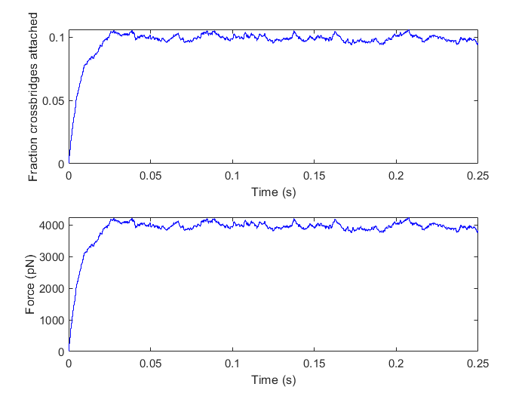

In figure 1, the upper part shows that after simulation starts, more and more attachment are established and finally reach a relatively stable state, at which average fraction is around 0.1. In the simulation, force generated by attached crossbridge is simply linear to the number of attachment, with a coefficient of 4 (unit pN). A fraction of 0.1 attachment is 1000, corresponding to 4000 in force.

Figure 2

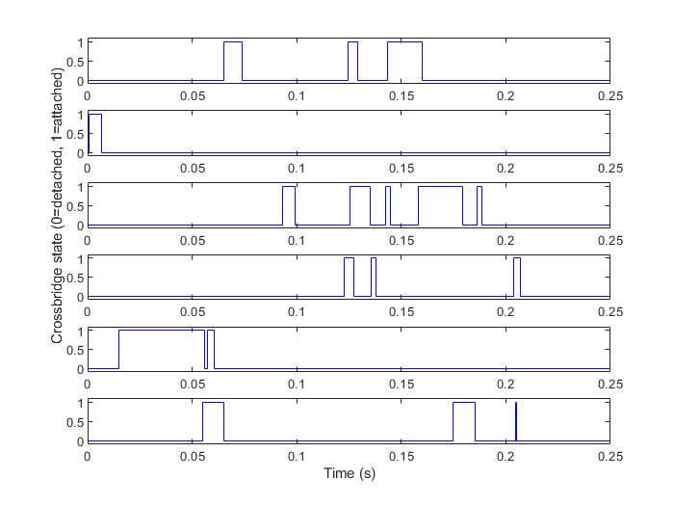

The results show the status of first 6 crossbridges during the simulation process. We can see that whether a crossbridge is attached or detached, and whether the current state change is randomly determined.

As I assumed in the first part, the fraction of attachment when stable probably determined by alpha and beta ratio, and the fraction would be simply alpha / (alpha + beta). By this assumption, when increasing alpha and keeping beta unchanged, attachment fraction would increase and verse visa. Generated force has the same tendency of attachment fraction.

**Binding and unbinding propensities**

1. Varying α

α = 14 (β = 126) α = 30 (β = 126)

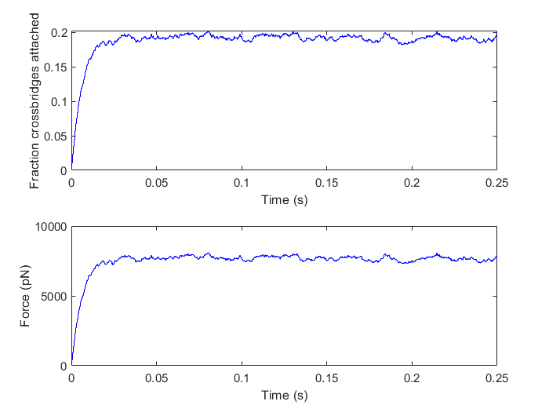

α = 50 (β = 126) α = 90 (β = 126)

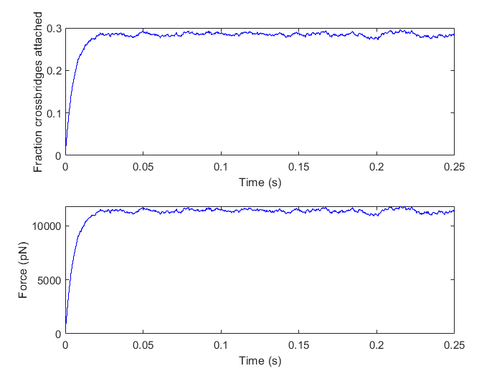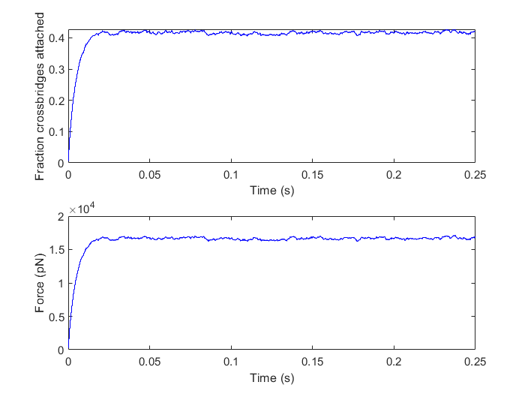

Results shown that as α was increasing, the fraction of attachment increased as I assumed. When α equals to 14, 30, 50, 90, α ratio in α / (α+β) is near 10%, 20%, 33%, 40%, as indicated by figures. Same tendencies could be seen in the figures of force. It seems that as α increased, there is reduced fluctuation of the fraction, as curve is rough when α = 14 and much smoother when α = 90.

The reason for a reducing fluctuation could be considered as, how many crossbriges are in attachment state follows a binomial model, with sample size 10000 and probability for success event is α.

By overlapping histograms of 10% range attachment of each case, we can see a more and more narrow peak. From outside to inside is α = 14, 30, 50 and 90.

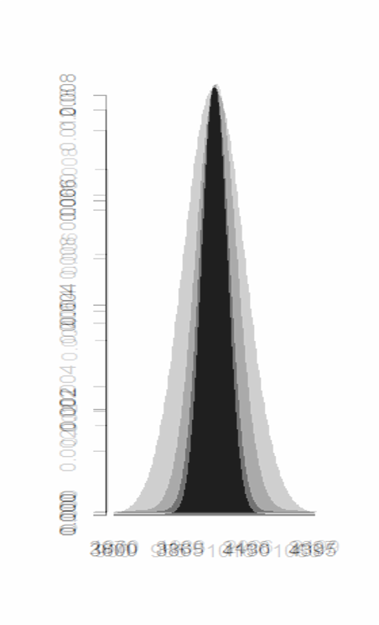

For the attachment and detachment kinetics, results are shown as below:

α = 14 (β = 126) α = 30 (β = 126)

 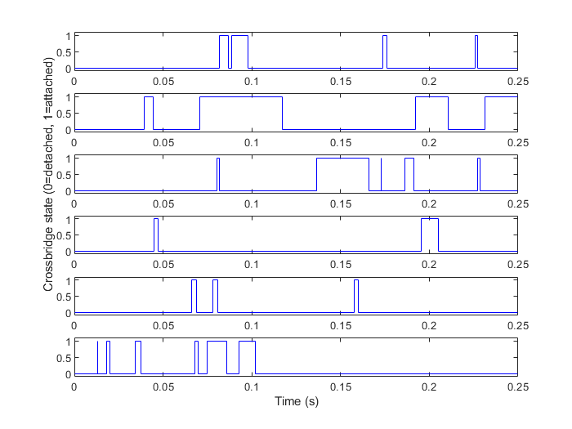

α = 50 (β = 126) α = 90 (β = 126)

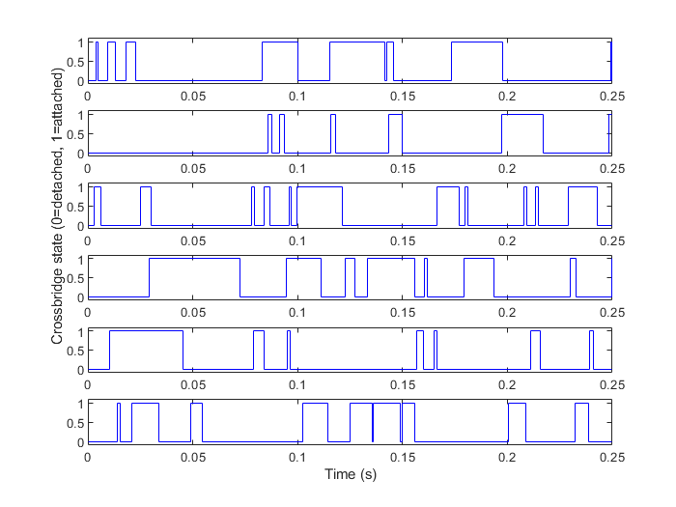 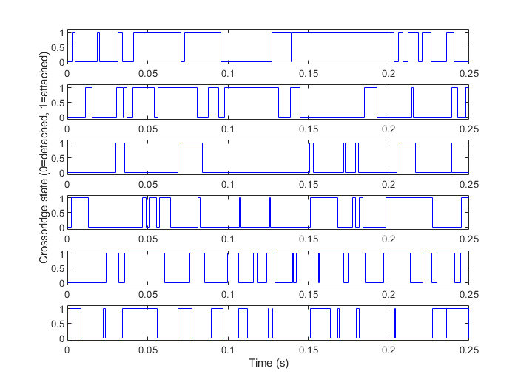

As α is increasing, the during of attachment of a single gate is also increasing. It is obvious in the figure when α = 90, we can see many platforms compare to that when α = 14, representing a greater probability for an open state.

2. Varying β

β = 126 (α = 14) β = 146 (α = 14)

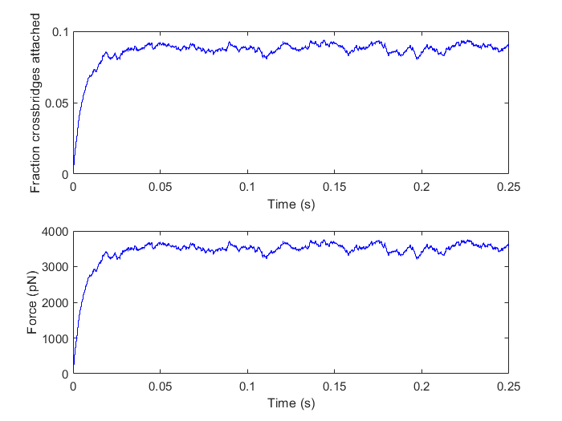

β = 186 (α = 14) β = 266 (α = 14)

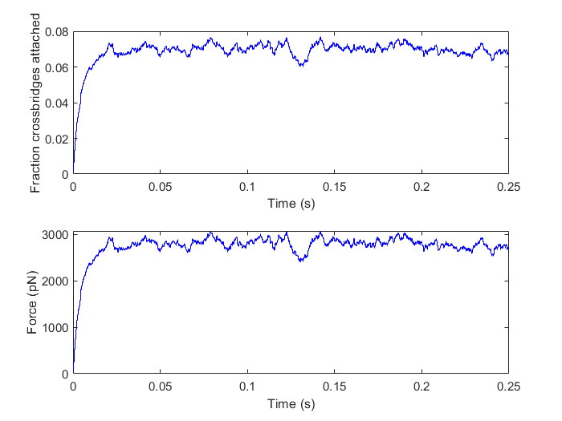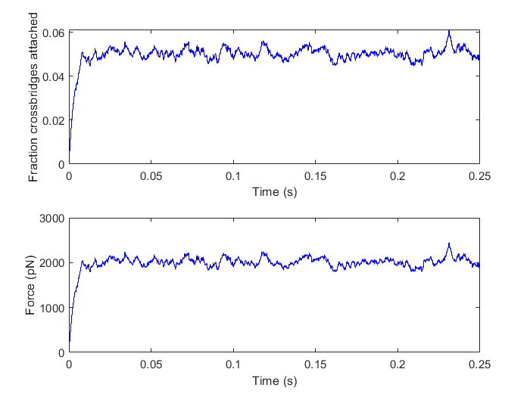

Results shown that as β was increasing, the fraction of attachment decreased. When β equals to 126, 146, 186, 266, α ratio in α / (α+β) is near 10%, 8.75%, 7%, 5%, as indicated by figures. Same tendencies could be seen in the figures of force. It seems that as β increased, there is raised fluctuation of the fraction, although the change is slight. Reason for this tendency is the decreasing α.

For the attachment and detachment kinetics, results are shown as below:

β = 126 (α = 14) β = 146 (α = 14)

 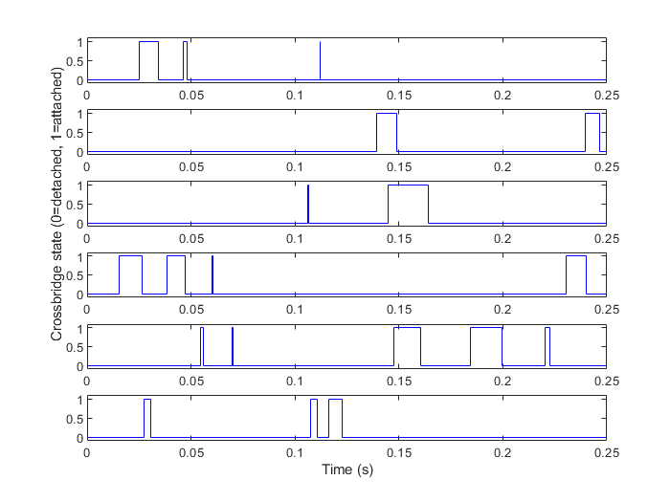

β = 186 (α = 14) β = 266 (α = 14)

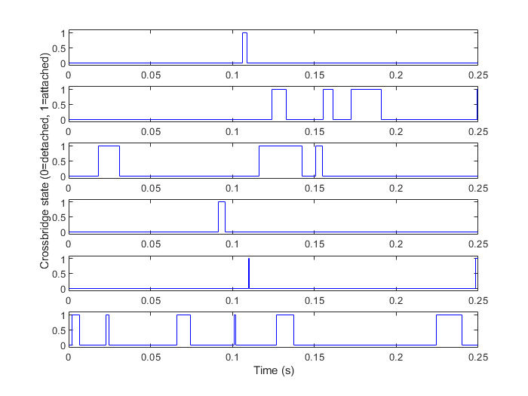 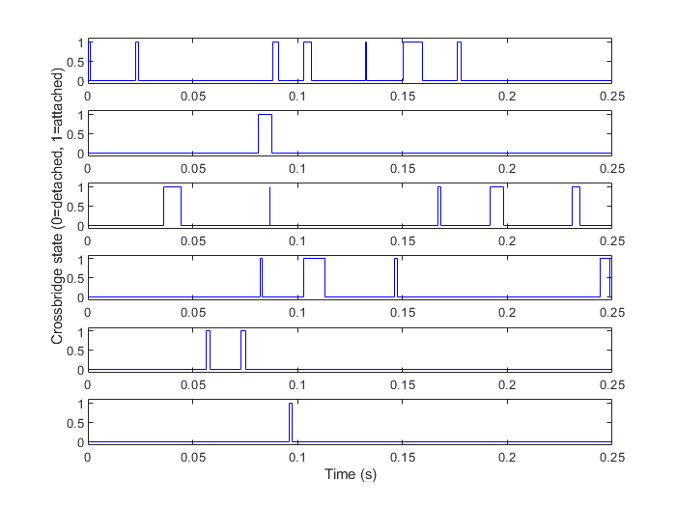

As β is increasing, the during of attachment of a single gate is decreasing. It is not obvious for a change in attachment/detachment kinetics, because the initial α / β ratio is small. Theoretically speaking, there would be less and less attachment states as β increasing.

3. Varying α and β together (α / (α + β) ration)

α = 14, β = 126 (ratio 0.1)



α = 28, β = 112 (ratio 0.2)

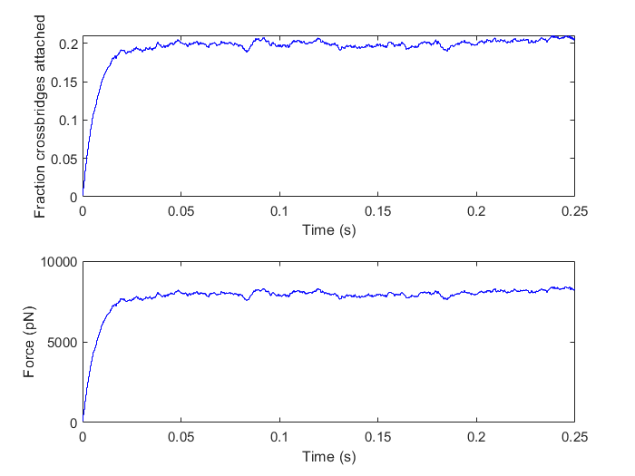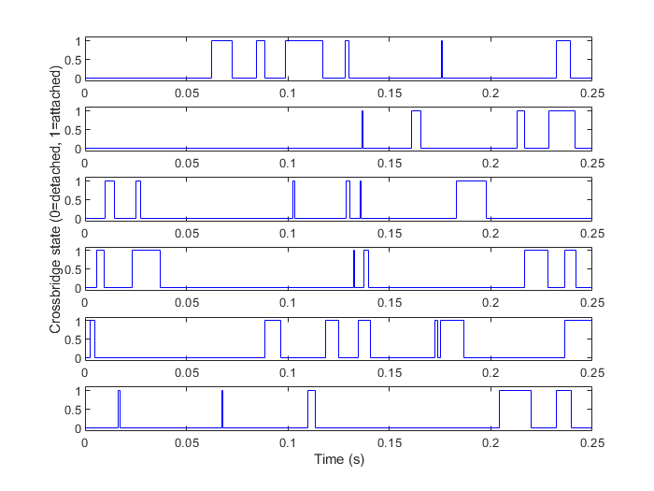

α = 35, β = 105 (ratio 0.25)

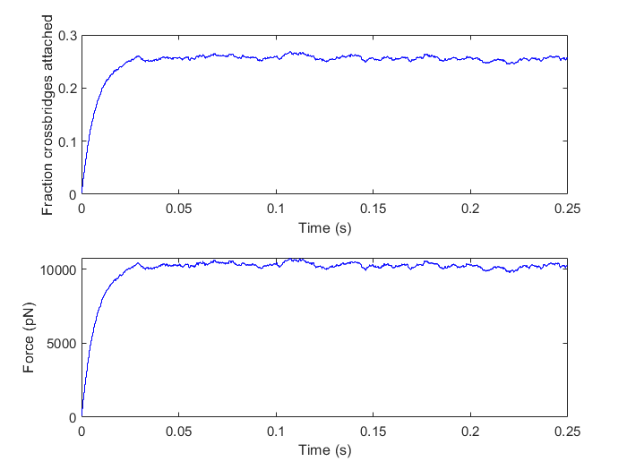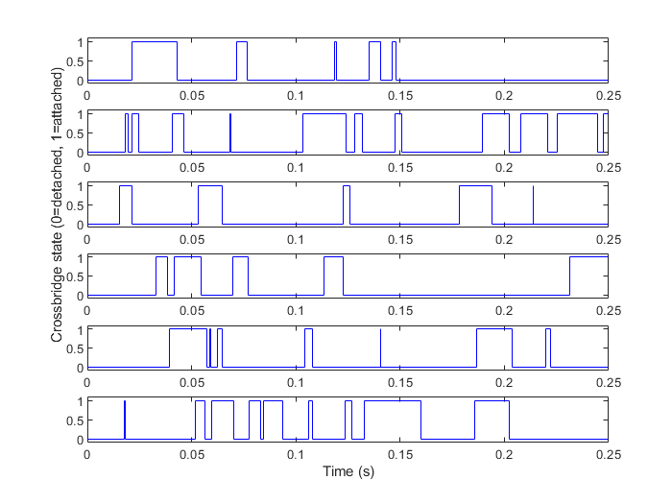

The effects on fraction and attachment and detachment are the same as increasing α.

**Number of crossbridges**

Scaling crossbridge number from 2000 to 20000, changing p1 accordingly to keep total force constant 40000. Use a vector to store the Psave after transient time. For a simulation during of 0.25, set t_transient to 0.10. For each n0, compute the coefficient of variation of P by std/mean.

Packing the simulation for each n0 as a function:

**function** **[**c**,** hist**]** **=** attraction**(**n**)**

alpha**=**14**;**

beta**=**126**;**

dt**=**0.01**/(**alpha**+**beta**);**

tend**=**0.25**;**

klokmax**=**tend**/**dt**;**

p1**=**40000**/**n**;**

t_transient **=** 0.10**;**

a**=**zeros**(**1**,**n**);**

**for** klok**=**1**:**klokmax

t**=**klok**\***dt**;**

prob**=(**beta**\***dt**)\***a**+(**alpha**\***dt**)*(**1**-**a**);**

change**=-**log**(**rand**(**1**,**n**))<**prob**;**

a**=**xor**(**change**,**a**);**

tsave**(**klok**)=**t**;**

Psave**(**klok**)=**p1**\***sum**(**a**);**

**end**

mini **=** min**(**find**(**tsave**>**t_transient**));**

l **=** length**(**tsave**);**

hist **=** Psave**(**mini**:**l**);**

m **=** mean**(**hist**);**

sd **=** std**(**hist**);**

c **=** sd**/**m**;**

**end**

Passing the scaling n0 into the function every iteration will yield the coefficient of variation of P and the Force vector after t_transient.

Histogram

n = 2000 n = 4000 n = 6000

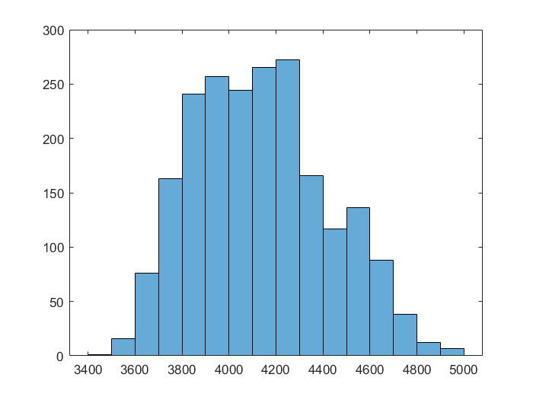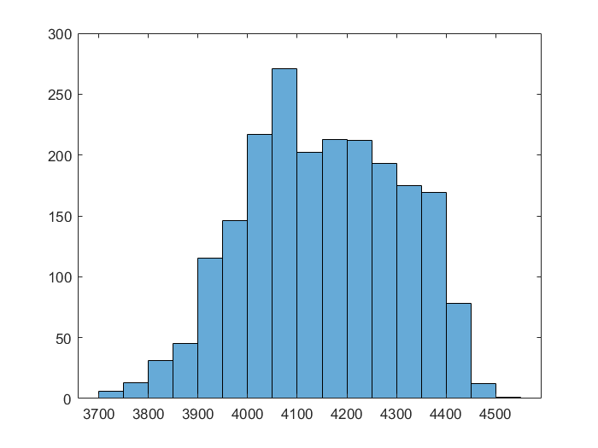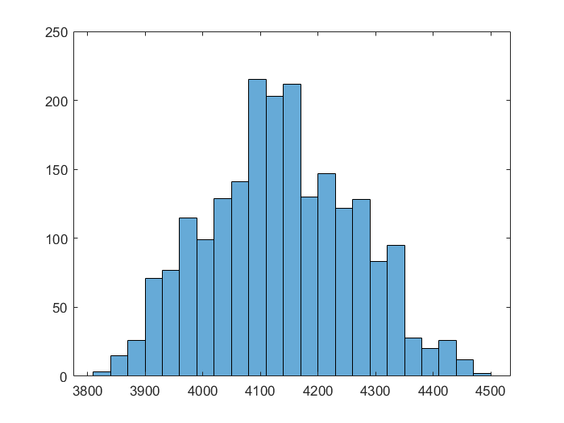

n = 8000 n = 10000 n = 12000

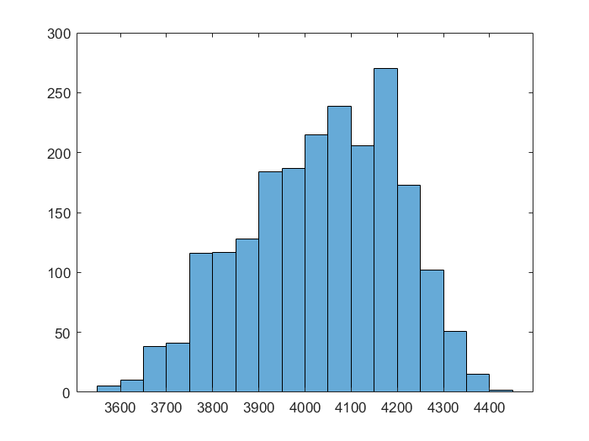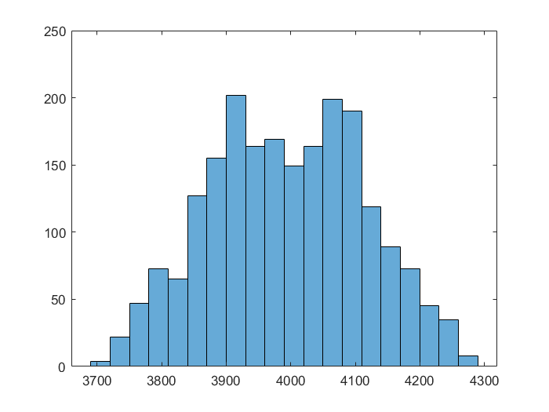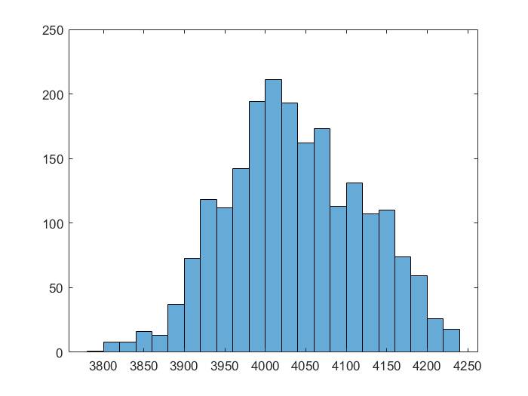

n = 14000 n = 16000 n = 18000

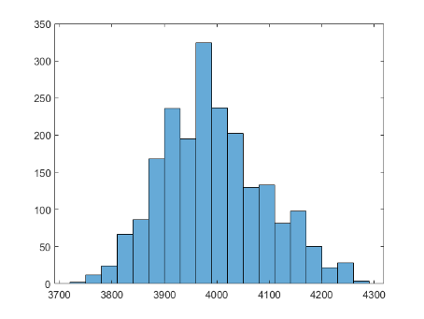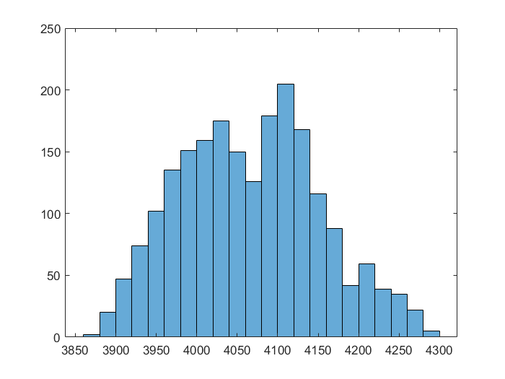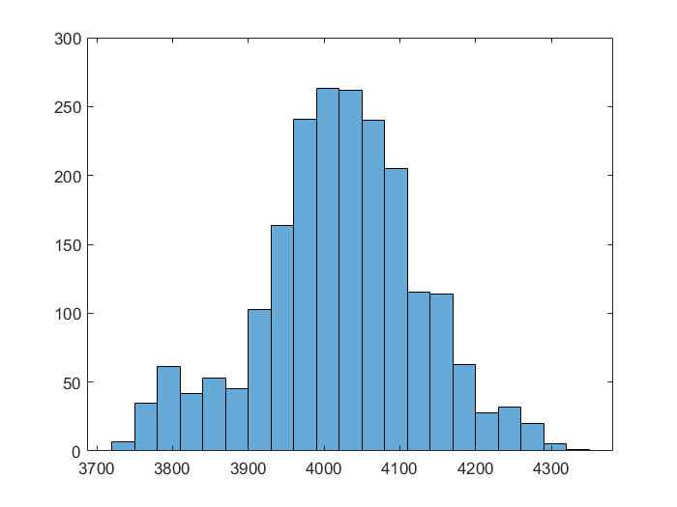

n = 20000

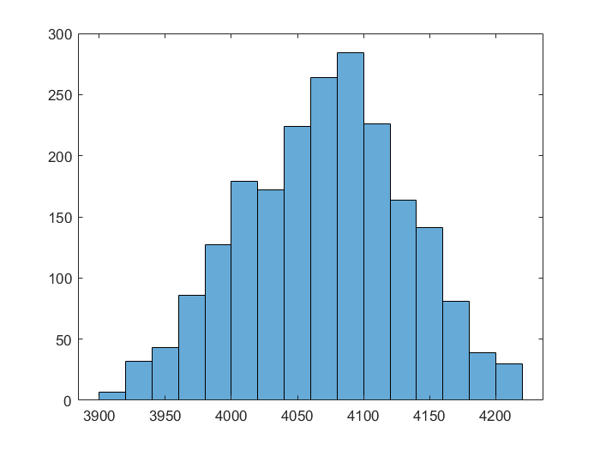

From the histogram figures, it is hard to draw the expected conclusion that as n getting larger, the distribution of P would be closer to a normal. Still the tendency can be seen as when n = 2000, there are kind of platform-like bar cluster, while when n = 20000, there is well bell-shape distribution.

Compute the coefficient of variant of P and use corresponding $1/\sqrt{n}$ as x-axis.

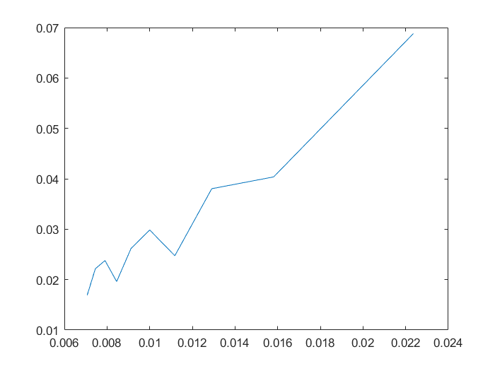

From the figure, coefficient of variation of P do scales as $1/\sqrt{n}$ thought not perfectly. The deviation is caused by randomly generated threshold and thus randomly changed states, giving a varied number of attachment and force.